**PRAYOSHA**

By

Prapti Jigneshbhai Patel (20BCA019)

Atmik Maheshbhai Virani (20BCA021)

Under Guidance

of

Internal Guide

Konica Soni

Submitted to

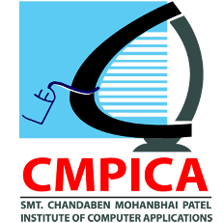

Smt. Chandaben Mohanbhai Patel Institute of Computer Applications

CHARUSAT

Changa

April/2022-2023 of Submission



[Accredited with Grade A+ by NAAC,](https://www.charusat.ac.in/)

CHAROTAR UNIVERSITY OF SCIENCE & TECHNOLOGY

Changa